Okta React Js Web App Integration

Below are the Steps for Integrating Okta Server with ReactJs Web Application

# OKTA Server Configurations

## Create Okta Dev Account

You can create Okta developer Account on [Okta Developer](https://developer.okta.com/signup/) portal.

Below is an example of Okta Developer Account created (for this Demo )

Developer Okta Account portal created : <http://dev-65193610.okta.com>

Server Admin : [prakhour@microsoft.com](mailto:prakhour@microsoft.com)

Password : *********

## Create New App integration for React App

Once the Okta Account is created , You can login to the new Okta account portal ( <http://dev-65193610.okta.com> as shown in this case ) using account credentials ( email and password ) as created in step 1.

Once you are logged in , You can navigate to Applications link and create a **App integration Token** using button “**Create App Integration**” button as shown in below screenshot.

Give any Name to the App registration ( for Eg .

Since we are going to use this App integration in React Web Application (with a Okta Sign In page) , so we will be selecting a **OIDC** ( Token based OAuth 2.0 Sign in method ) and ApplicationType as **Single Page Application** as shown below .

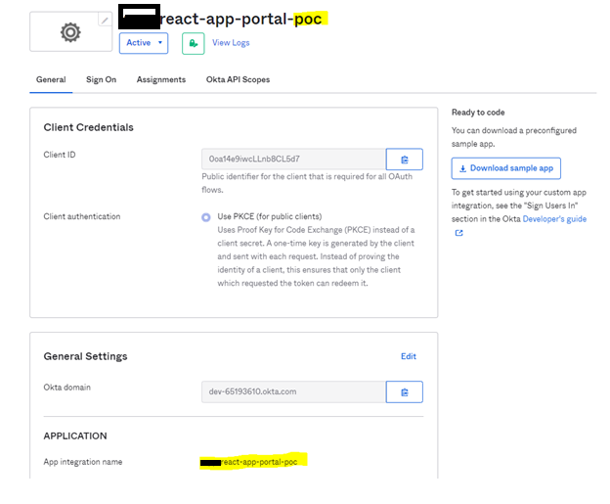

Note the Client ID as it will be used in ReactJs app Okta sign in parameter section.

Select Grant Type : **Implicit**

andIn SignIn redirect Url as **http://localhost:3000/implicit /callback**

Note : We will integrate implicit callback url in our React Js application signin parameters section

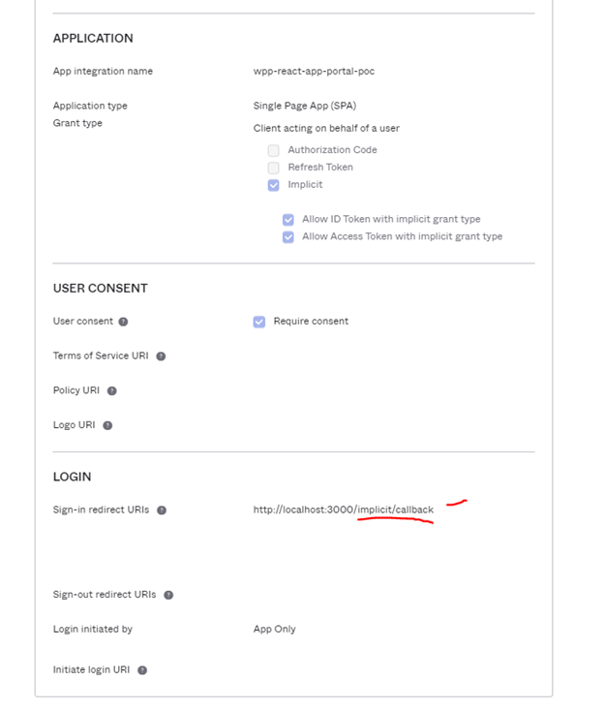

Additionally , You can also specify Sign out redirect Url same as login page url.

## Enable CORS on Okta Developer portal for the react app login url

To enable CORS for our web app , Go to **Security > API > Trusted Origins** tab

Click **Add Origin** button

You can provide a **Name** for this origin (say localhost:3000)

Type **Origin Url** as <http://localhost:3000>

(note we are using 3000 port number as ReactJs app runs on port 3000 by default in local debug mode ) Port can be changed to local debug react app port number.

Select the **2 checkboxes** and **Save**

New *Localhost:3000* Origin will get added to the list

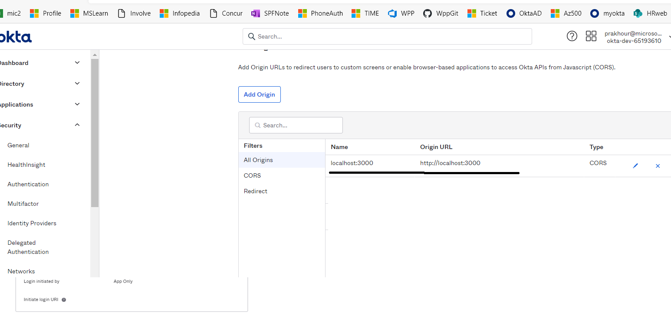

**NOTE** : Under Authorization Servers , there must be a default authorization server settings already created for the okta developer portal . We will be using this authorization server in react app for pour demo



## Add other Okta users and assign to App integrations

You can add login user to your react App in Okta porta under the below section

Goto **Directory > People** > Click **Add Person**

Search for the **First name , Last name , Email id** of the user to be added . Then click **Save**.

NOTE : A mail will be sent to the recipient user to accept the Okta login invitation and will be asked to reset password. After this activity the recipient user will be able to login to the Okta server using the set credentials.

New user will get added to the list .

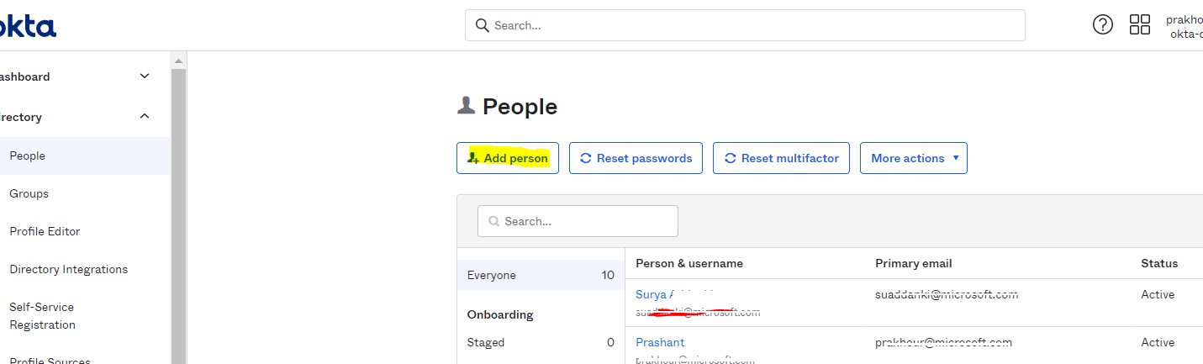

Now Confirm/Add User Assigment

Goto existing **App integrations** (react-app-portal-poc) > **Assignment** tab

Select **Assign > Assign to People**

In the new pop up window **,Search** the new user email id ,you want to add to the list and click **Assign** .

Click **Done** to add to the list of assigned users .

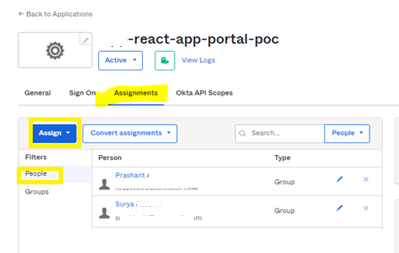

# Build React Js Application with Okta Server

Refer/Download the Okta Sign In ReactApp code attachment provided with this document.

( OktaReactAppIP.zip )

Refer package.lock.json file has below react and okta package dependencies added to it :

react-router-dom

@okat/okta-react

@okta/okta-signin-widget

Refer the Configuration sections in App.Js file where the Okta developer server url is mentioned with the

App integration Client ID

Open the Code in VS Code

Install the okta packages using below command

* **npm i react-router-dom @okta/okta-react @okta/orkta-signin-widget**

Run the Application using below commands in terminal

* **npm install**

* Run command **npm run start**

You should get the Okta Signin page hosted on <http://localhost:3000/>

Type in your oktas user credentials (email id & password ) as registered with Okta earlier.

You should be redirected to home page on Successful login.

# Okta React Portal Demo Screenshots

Startup page : click the button “start Okta React Demo “

Okta Sign-In page : Enter your Okta user credentials

Home Page : **Home** is the page displayed on successful login to Okta React portal

My Details : Click on **My Details** to view login user details as fetched in the authentication token sent by Okta Server.

SignOut : Click Sign Out link to logout from Okta react demo application and move back to startup page

